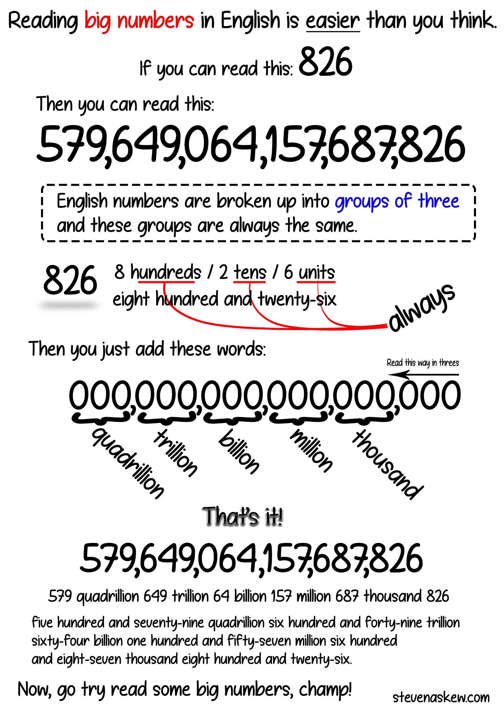

Try reading these long numbers. The answers are at the bottom.

1. 684,546,289
2. 492,012
3. 978,805,426,854
4. 458,013,814,444
5. 89,184,254
6. 45,154,548,894,684,154
7. 1,379,000,000
8. 467,821
9. 457,793,290,493,209
10. 923,598,323,090,489,000

Test your friend. Make up some numbers. Can your friend read them?

1. ____________________________
2. ____________________________
3. ____________________________
4. ____________________________
5. ____________________________
6. ____________________________

Can you read your friend’s numbers?

Answers:
1. six hundred and eight-four million five hundred and forty-six thousand two hundred and eighty-nine
2. four hundred and ninety-two thousand and twelve
3. nine hundred and seventy-eight trillion eight hundred and five million four hundred and twenty-six thousand eight hundred and fifty-four
4. four hundred and fifty-eight billion thirteen million eight hundred and fourteen thousand four hundred and forty-four
5. eighty-nine million one hundred and eighty-four thousand two hundred and fifty-four
6. forty-five quadrillion one hundred and fifty-four trillion five hundred and forty-eight billion eight hundred and ninety-four million six hundred and eighty-four thousand one hundred and fifty-four
7. one billion three hundred and seventy-nine million (The population of China 2016)
8. four hundred and sixty-seven thousand eight hundred and twenty-one
9. four hundred and fifty-seven trillion seven hundred and ninety-three billion two hundred and ninety million four hundred and ninety-three thousand two hundred and nine
10. nine hundred and twenty-three quadrillion five hundred and ninety-eight trillion three hundred and twenty-three billion ninety million four hundred and eighty-nine thousand

